

Research Project Proposal

Topic: **CINEMA BOX OFFICE MOBILE APPLICATION**

**FACULTY**: Information Technology

**DEPARTMENT**: software engineering

**Prepared by:**

**Names:** Mushimiyimana Florence

**Id:**#20100

**Phone**: +250788754620

**Email**: [mushimiyflora20@gmail.com](mailto:mushimiyflora20@gmail.com)

*Done at Kigali, On11th* November,2019

# ***Background of the study***

The Century Theater chain was originally named Syufy Enterprises, for its founder Raymond Syufy, Senior, who built his first theater in [Vallejo, California](https://en.wikipedia.org/wiki/Vallejo,_California) in 1941. The first Century theater was the Century 21 in [San Jose, California](https://en.wikipedia.org/wiki/San_Jose,_California), which opened in 1963, adjacent to the [Winchester Mystery House](https://en.wikipedia.org/wiki/Winchester_Mystery_House). The Century 21 theater was built to showcase [Cinerama](https://en.wikipedia.org/wiki/Cinerama) type movies (the left and right empty projection booths are still present), but in fact, it showed only 70mm movies. The screen was later replaced with a flat model, and has remained intact as a throwback to the domed Cinerama palaces of the 1960s. The "Century 21" name was a tactic used to convey to the viewing public a "futuristic image". This image is bolstered by the lobby's distinct modern "bubbled lights" and metallic gold accents. The large orange metal ornament on the top of the domed-theater was functional in addition to being decorative—theater employees rappelled from it when the dome's outer track-lighting needed to be maintained. The first film presented at the Century 21 was [*It's a Mad, Mad, Mad, Mad World*](https://en.wikipedia.org/wiki/It%27s_a_Mad,_Mad,_Mad,_Mad_World) in 70mm format.

Century Cinema opened in May 2013, it is located in the center of Kigali on the third floor of Kigali city tower, and Century Cinema is a great addition to Rwanda’s entertainment. The movie theatre shows current releases in 2D, 3D, and 5D an experience that immerses the audience in the world of the film they are enjoying. Century Cinema offers a good service to bring and show the latest movies to its customers. Century Cinema has good theatres of an international standard and it’s the only one in Kigali and also only in Rwanda. This is a contributing step to the development of Kigali city (Rwanda).

# *Project Objectives*

1. **General Objective**

The main objective of this study to develop an android mobile application that can provide a flexible and simple way to customers to access updated information and booking for a cinema ticket.

### *Specific Objectives*

* It will provide updated information on movies.
* Cinema box office mobile application will allow users to search and purchase tickets.
* The administrator can follow up the prominence movies.
* Another objective of this project is to design a well-organized web-based and android system which will help users to purchase movie tickets instantly.
* Time will be saved as there won’t be queue.
* It will provide booking system

# *Problem statement*

With the current system that is deployed at Century Cinema it’s very difficult for customers to access the updated information due to website; the system is also not compatible with phones.

The main problems that motivated me to create this implementation a cinema mobile application:

* Waste of time spent standing on a queue while buying ticket.
* No booking system

# *Proposed Solution*

Considering our country’s vision of automating almost every system, I came up with the idea of solving the existing system by creating an android application and a web-based system which will be used to easily buy tickets. Cinema box office mobile application will help the user to check some featured movies. This will avoid the struggle of the user whereby he/she would go to the cinema house and check on airing movies so that he/she would buy tickets.

# MODULES OF THE SYSTEM

* ***Public pages module:***
* These modules are valuable in providing information to a visitor (login is not required) about the website and contact address and numbers. The homepage shows the main features of the website.
* ***Medical store module:***
* These modules consist of adding a new medicine to list, managing existing Medicines List, and edit or Update medicines stock and maintain the application settings
* ***Medicine search modules:***
* These modules consist of Search and advanced search by providing search results and search results filtration
* ***Mobile modules:***
* These modules consist of SMS notifications and the mobile application of the system.
* ***Admin module (operator):***
* These modules allow an administrator of the website to manage master data and also manage Medical

**Requirements**

***VI.1.Functional Requirements***

* The mobile application will allow users to register.
* The mobile application will allow users to book a seat
* The mobile application will allow users the cancelation of the ticket
* The Admin should be able to manage movies
* To implement a mobile application that shall be able to run on various android devices.

#### VI.2 Non-Fuctional Requirements

* **Maintainability:**
  + - The system should be easily to maintain it, once is needed
* **Security:**
  + - The system must be able to hide the users information
    - The password for user must be made of at least 6 characters
    - The System will block you once you clicks 5 times on login steps
* **Operational:**
  + - The system should be able to run on any OS.
* **User friendly:**
  + - The System will be user friendly
    - The system must be easy for a user to use.
* **Privacy:**
  + - The system shall be able to protect the users privacy
* **Availability:**
  + - The system shall have high availability
    - The system shall not have unexpected downtime

**Technologies and Tools to be Used**

**Tools to be used**

PHPSTORM IDE: will be used to code php.

MYSQL: Will be used as DBMS to create the database.

EDRAW: Will be used for designing diagrams.

**Languages**

PHP: for the server side of the web system

JAVA: for mobile app

JAVASCRIPT & HTML: will be used to create web pages.

**Work Breakdown Structure**

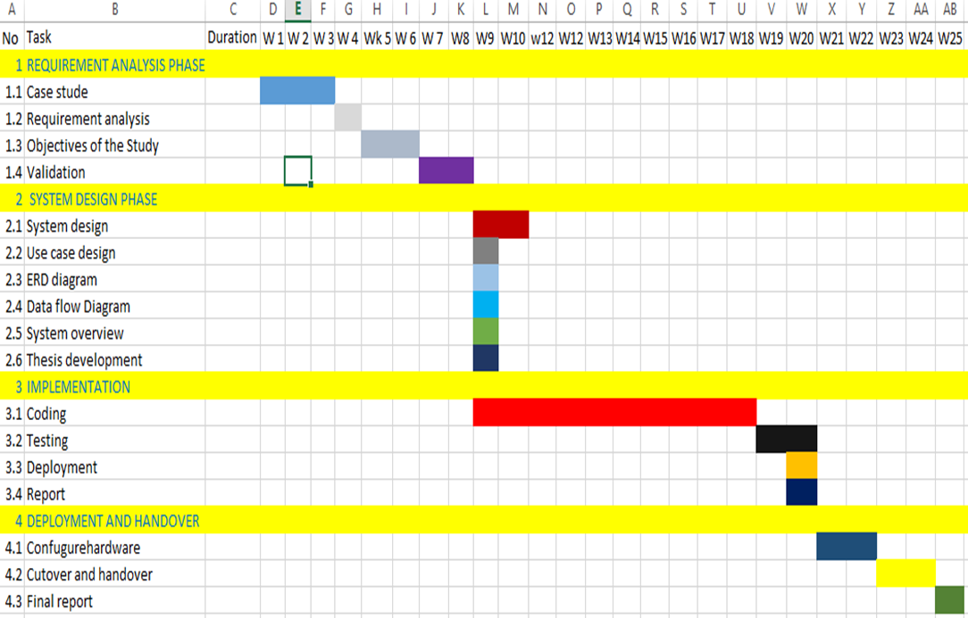

**Project Plan**

|  |  |  |  |  |  |  |  |
| --- | --- | --- | --- | --- | --- | --- | --- |
| Task Id | Task Names | | Duration | | Status | | |
|  | | | | | | | |
| 1. Requirement Analysis 1.5 months | | | | | | | |
| 1.1 | Analysis Existing System | | 1 Week | | | Open | |
| 1.2 | Description of the Existing System | | 1 Week | | | Open | |
| 1.3 | Analysis a new System | | 1 Week and half | | | Open | |
| 1.4 | Determine project requirement | | 4 Days | | | Open | |
| 1.5 | Meet a Supervisor | | 1 Week | | | Open | |
| 1. System Design 1 month | | | | | | | |
|  | | | | | | | |
| 2.1 | Architecture | | 1 Week | | | Open | |
| 2.2 | Database Design | | 1 Week | | | Open | |
| 2.3 | UI design/ Program Design | | 1 Week | | | Open | |
| 2.4 | Meet a Supervisor | | 1 Week | | | Open | |
|  | | | | | | | |
| 1. System Implementation 1.5 months | | | | | | | |
| 3.1 | Coding | | 3 Weeks | | | Open | |
| 3.2 | Testing | | 1 Week | | | Open | |
| 3.3 | Execution | | 1 Week | | | Open | |
| 3.4 | Meet a Supervisor | | 1 Week | | | Open | |
| 4. Deployment 2 Weeks | | | | | | | |
| 4.1 | | Final report | | 1 Weeks | | | Open |
| 4.2 | | Writing report | | 4 Weeks | | | Open |
| 4.3 | | Meet a Supervisor | | 2 Weeks | | | Open |